Run’em Gun’em
By: Jeremy Thomas, Ryan Sweeny
Intro:
Join the ranks of the most elite snipers in this one button first person shooter. Test your skills and kill some baddies in this interactive, simple to learn, but difficult to master shooter. Build your way up the ranks of the newly established Erie-Canadian mafia.
Rough Plot:
As a new recruit gun runner for the Matt White Erie-Canadian Mafia you will work your way up the ranks, showing Dr. White what you have in store. Build your skills and upgrade your sights and clip capacity. Go from job to job and show them your abilities. Before each mission you will prepare yourself for what you must do. The only thing you are given beforehand is a slip of paper with a short description of your target. It’s your job to find and eliminate the target. Otherwise eliminate or be eliminated.
Character Bio:
Without a job, home or even family and friends things take a turn for the worse and you decide that you’ve had enough. This is when you meet Dr. Matthew White who is trying to spread his influence on the Erie-Canadian Mafia.
Gameplay:
At the beginning of each mission you will have a choice on what upgrades you would like to purchase. If you buy an upgrade, it is automatically equipped and you can use it in the next mission. You cycle through the menu items by pressing the action button, and select an item by holding the action button. The mission begins as you read a slip of paper identifying the target. It will give you certain characteristics like “Wearing a red scarf”. After you read the note you will push the action button to start. As the mission begins, you will be looking through your scope (which is locked in place) and a certain number of people will walk into your view; all of which are innocent except for your target. However, there might be multiple people in your scope at the same time. You will be scored on how many shots you take, how fast you complete your mission, and how many other casualties you take in the process. If you do not shoot the target within a given time, you will fail the mission and automatically be eliminated. When you PUSH and HOLD the action button down your view will move from right to left across the gameplay area. When you let go of the button, the scope will stop where it was at when the button was released. If you give the action button a short TAP with no HOLD then you will fire your weapon. You will have a certain number of shells per clip and you are limited to one clip per mission. Upgrades include better scopes (increased zoom, infrared, etc.) and larger clips.
Art Breakdown:
Refer to attached concept art.
Art Assets:
- Background Colors
- Action button graphics
- Target Graphics
- Upgrade Screen Graphics
Text Assets:
- Target Descriptions
- Upgrade Descriptions
Tech Assets:
- Flash Programming
- Adobe Flash CS6
- Adobe Fireworks CS6
- Microsoft Paint
- Android SDK, iOS SDK(apple)
- Objective-c programming for Apple and Java programming for Android.
Marketing Plan:
Projected age group: 12 and up.
Outlets: Android application, IPod/pad application. Web based game sites (addicting games).

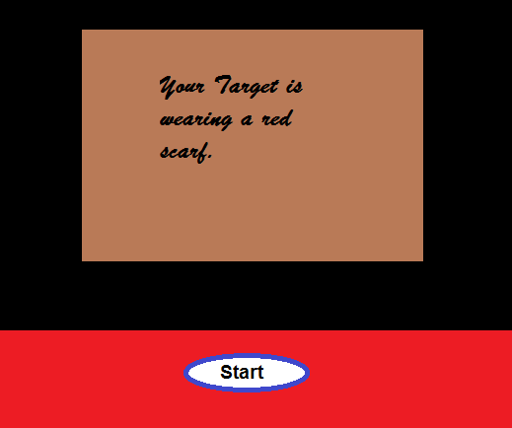
CG ART- The Target info
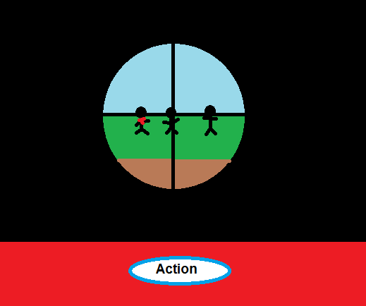
Environment Art- Player game Screen

